Processor utilization factor and Schedulability analysis
The processor utilization factor is a measure used in real-time systems to quantify the proportion of the processor's time that is being utilized by tasks. It helps in determining whether the tasks can be scheduled to meet their deadlines. The utilization factor is particularly important in scheduling algorithms like Rate Monotonic Scheduling (RMS) and Earliest Deadline First (EDF).

Definition
The processor utilization factor U is defined as the sum of the utilization of all tasks in the system. For a set of n periodic tasks, where each task Ti has a computation time Ci​ and a period Ti​, the utilization factor U is given by:
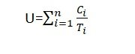

Key Points
- Computation Time (Ci) : The worst-case execution time of task Ti.
- Period (Ti) : The time interval between successive activations of task Ti.
If the processor utilization is greater than one, then that task set will not be schedulable by any algorithm.
Schedulability analysis
The processor utilization factor is closely related to Schedulability analysis, which is the process of determining whether a set of tasks can be scheduled to meet their deadlines under a given scheduling algorithm. Here's how the utilization factor plays a role in Schedulability analysis for some common real-time scheduling algorithms:

Rate Monotonic Scheduling (RMS)
Rate Monotonic Scheduling (RMS) is a fixed-priority algorithm where tasks with shorter periods have higher priority. The Schedulability condition for RMS involves the utilization factor.

Utilization Bound for RMS
For n periodic tasks, RMS guarantees that all deadlines will be met if the total utilization U satisfies:
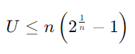
This bound is known as the Liu and Layland bound. As nnn increases, the bound approaches approximately 69.3%. If the total utilization is within this bound, the task set is guaranteed to be schedulable.

Earliest Deadline First (EDF)
Earliest Deadline First (EDF) is a dynamic priority algorithm where tasks with earlier deadlines have higher priority.

Utilization Bound for EDF
EDF has a simpler utilization-based Schedulability test. A set of periodic tasks is schedulable under EDF if the total utilization U satisfies:
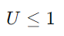
This means that EDF can fully utilize the processor up to 100%. If the total utilization exceeds 1, the task set is not guaranteed to be schedulable.

Example: Schedulability Analysis
Let's consider a set of three periodic tasks with the following parameters:
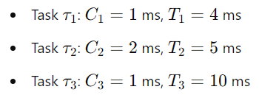
First, calculate the utilization factor U:
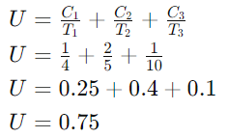

RMS Analysis
For three tasks (n=3), the utilization bound is:
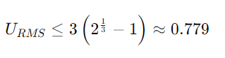
Since U=0.75≤0.779, the task set is schedulable under RMS.

EDF Analysis
For EDF, the utilization bound is simply:
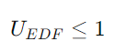
Since U=0.75≤1, the task set is schedulable under EDF.

Summary
The processor utilization factor is a crucial metric in schedulability analysis:
- RMS: The task set is schedulable if the total utilization is within the Liu and Layland bound, which depends on the number of tasks.
- EDF: The task set is schedulable if the total utilization is less than or equal to 1.
Utilization-based tests provide a straightforward way to check if a given set of periodic tasks can be scheduled to meet their deadlines under specific scheduling algorithms.

